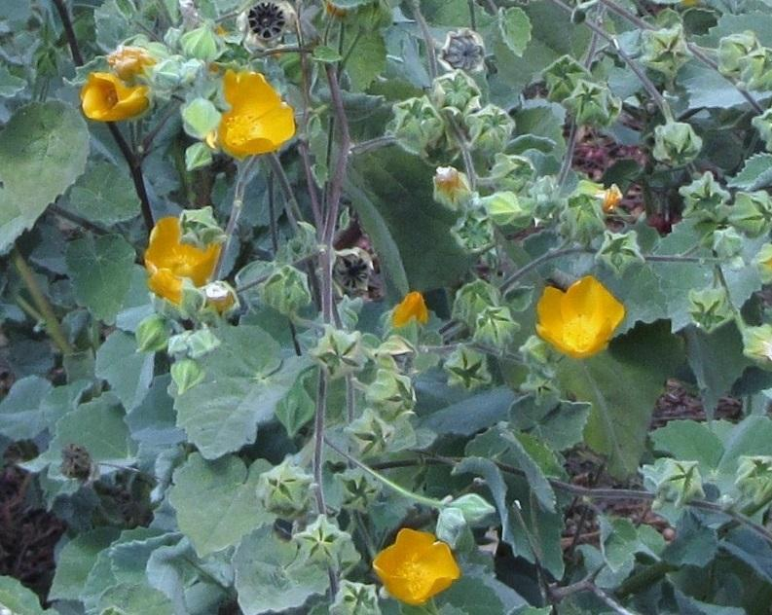
#1

Scientific Name: Abutilon palmeri

Common Name: Palmer's Indian Mallow
Soil PH: 6.0 - 8.0
Height: 3 - 8 ft
Width: 3 - 5 ft
Sun/Shade Needs: Full Sun
Water Needs: Extremely Low Very Low Low Moderate-High
Attracts: butterflies
DESCRIPTION: Palmer's Abutilon (Abutilon palmeri) is a relatively rare species of the Malvaceae Family (mallows) native the southwestern U.S. and northern Mexico that grows primarily on eastern slopes. Flowers are cup-shaped with 5 petals and are approximately one inch in size. Branches and stems are also hairy with a red-brown coloring to the twigs. Bark ranges from green to brown. It is a rugged and strong plant that is easy to grow. For best results, plant in rocky or sandy well-draining soil. Can tolerate occasional light summer watering.
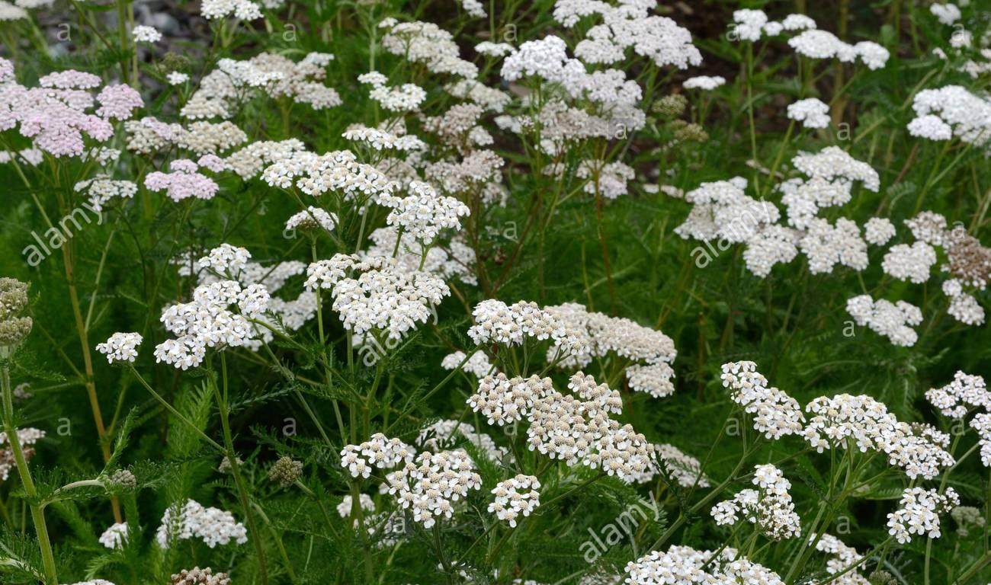
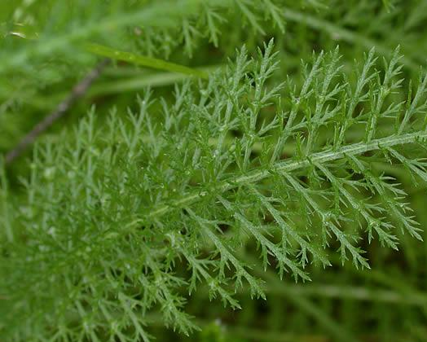
#2

Scientific Name: Achillea millefolium

Common Name: Common Yarrow
Soil PH: 4.0 - 8.0
Height: 1 - 3 ft
Width: .5 - 1.5 ft
Sun/Shade Needs: Sun, Part Shade, Full Shade
Water Needs: Extremely Low Very Low Low Moderate-High
Attracts: Bees and butterflies
DESCRIPTION: Yarrow is a flowering plant in the family Asteraceae, native to the Northern Hemisphere. It commonly flowers from May through June, and is a frequent component in butterfly gardens. Common yarrow is frequently found in mildly disturbed soil of grasslands and open forests. Actively grows in the spring.
This plant is extremely easy to grow, but looks best with regular water. It easily reseeds though it can be aggressive.
In antiquity, yarrow was known as herbal militaris, for its use in staunching the flow of blood from wounds. Native Americans had many uses for the plant, including pain relief, fever reduction, and blood issues of all kinds.

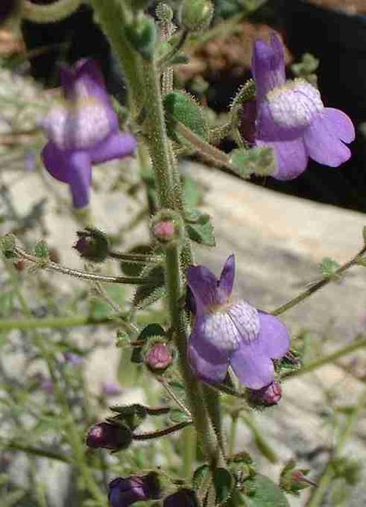
#5

Scientific Name: Antirrhinum Nuttallianum

Common Name: Violet Snapdragon
Soil PH: 6.0 - 8.0
Height: 1 – 3 ft
Width: 1 - 3 ft

Sun/Shade Needs: Full Sun
Water Needs: Extremely Low Very Low Low Moderate-High
Attracts: Bees, butterflies, hummingbirds, larva
DESCRIPTION: Violet Snapdragon is a species of New World snapdragon in the Plantaginaceae family known by the common names Nuttall's Snapdragon. It is native to southern California and Baja California, where it can be found from the immediate coastline to the inland coastal ranges. This is an annual or biennial herb producing an erect, vine-like stem which sometimes clings to objects for support but does not twine as tightly as many other snapdragons. The flowers are veined light purple with white patches and around a centimeter long. Each is borne on a short pedicel.

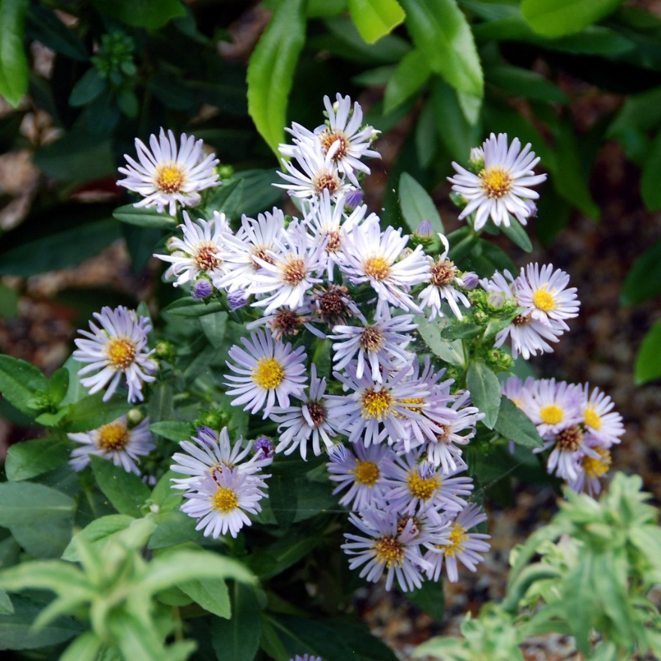
#7
Scientific Name: Aster Chilensis 'Point Saint George'

Common Name: Point St. George Aster
Soil PH: 5.8 - 8.0
Height: .3 – 1 ft
Width: 2 - 3 ft

Sun/Shade Needs: Full Sun, Partial Shade
Water Needs: Extremely Low Very Low Low Moderate-High
Attracts: Bees, birds, butterflies
DESCRIPTION: This native perennial has showy lavender flowers that last from summer through fall. It is a groundcover selection of the species that spreads rapidly which makes it a great option for borders, or containers or as a lawn substitute. It will bear light traffic. This plant grows from rhizomes, so some form of edging to contain its eventual spread and keep it in bounds should be considered when planting. It attracts both butterflies and birds which make it a great choice for both butterfly and bird gardens especially since the flowers bloom in summer and fall when most plants have stopped flowering.
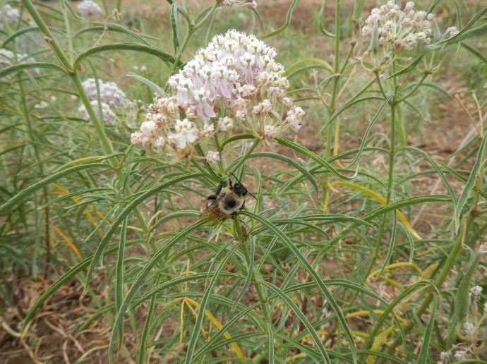
#8

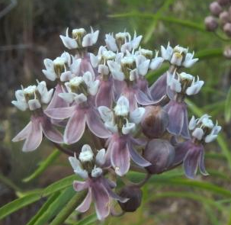
Scientific Name: Asclepias fascicularis

Common Name: Narrow Leaf Milkweed
Soil PH: 6.0 - 8.0
Height: 1.7 - 3.3 ft
Width: 1 ft
Sun/Shade Needs: Full Sun
Water Needs: Extremely Low Very Low Low Moderate-High
Attracts: Butterflies – specifically the monarch butterfly!
DESCRIPTION: Narrowleaf milkweed (not to be confused with tropical milkweed) is a flowering perennial sending up many thin, erect stems and bearing distinctive long pointed leaves. It blooms in clusters of lavender or lavender-tinted white flowers. Easy to grow in soils with good drainage, even with no summer water and has the potential to become weedy.
Milkweeds are the most important larval host plants for Monarch butterflies in California. Be prepared for the plant to be eaten by Monarch caterpillars, but will be rewarded by the presence of beautiful Monarch Butterflies. The plant is deciduous in winter and will sometimes die back to the ground before reviving in the Spring so it is often best to plant in less prominent spots in a garden.
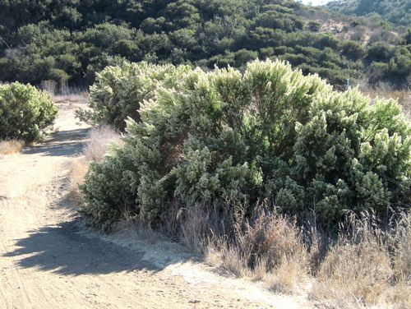
#9
Scientific Name: Baccharis Pilularis

Common Name: Coyote Bush
Soil PH: 5.8 - 8.0
Height: 1.5 – 10 ft
Width: 12 ft

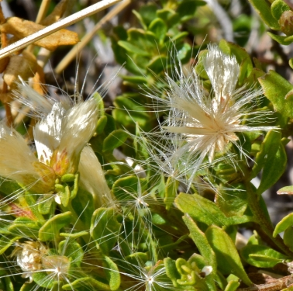
Sun/Shade Needs: Full Sun, Partial Shade
Water Needs: Extremely Low Very Low Low Moderate-High
Attracts: Bees, birds, butterflies, larva

DESCRIPTION: Coyote Brush (or Bush) is a common shrub in the Asteraceae that grows in California, Oregon, and Baja California. It is smooth and generally sticky. The stems are prostrate to erect which branches spreading or ascending. The leaves are 8-55 millimeters long with three principal veins and have profuse, white or yellow, rayless flowers that bloom in early winter. They are found in a variety of habitats, from coastal bluffs to oak woodlands. Coyote Brush is extremely easy to grow.

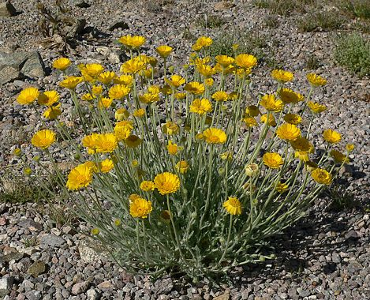
#11

Scientific Name: Baileya Multiradiata

Common Name: Desert Marigold
Soil PH: 7.0 - 9.0
Height: 1.6 – 2 ft
Width: 1 – 1.3 ft

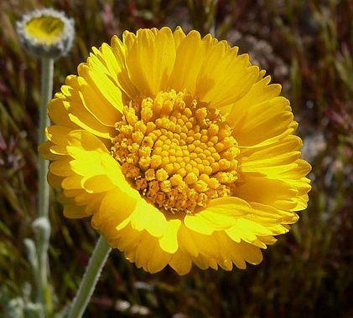
Sun/Shade Needs: Full Sun
Water Needs: Extremely Low Very Low Low Moderate-High
Attracts: Bees, butterflies, larva

DESCRIPTION: Desert Marigold is a species of sun-loving wildflower native to western North America. It is an annual or perennial clumping patch of silvery-green foliage which bears many tall, naked stems, each topped with a bright yellow marigold-like flower. The bloom loses its ray florets early, leaving behind a nodding stalk where the seeds develop. In the garden give it fast drainage, not too much water and lots of surface rocks. It is somewhat short-lived as a perennial but readily re-seeds itself if conditions are right.

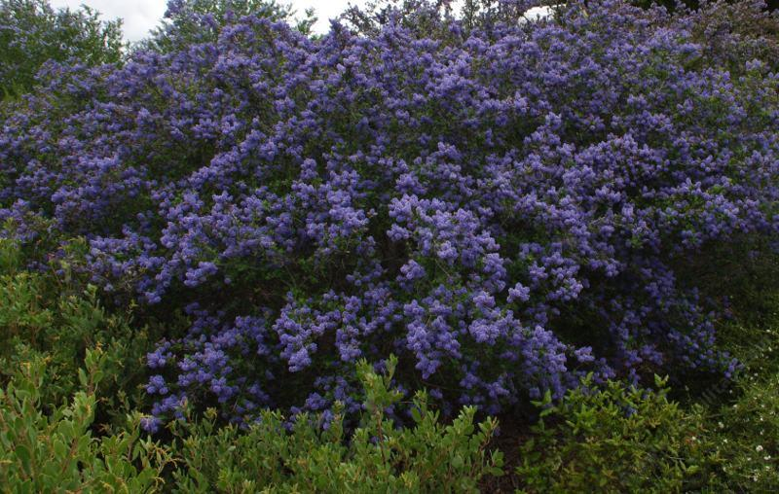
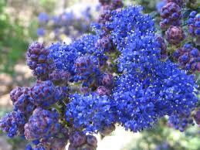
#14

Scientific Name: Ceanothus Frosty Blue

Common Name: California Lilac
Soil PH: 5.0 - 8.0
Height: 6 - 9 ft
Width: 6 - 9 ft
Sun/Shade Needs: Full Sun, Part Shade
Water Needs: Extremely Low Very Low Low Moderate-High
Attracts: Butterflies and bees
DESCRIPTION: Ceanothus 'Frosty Blue' is an evergreen mountain lilac that grows to six or eight feet tall and about as wide. A little nipping here and there can move it taller or narrower. The flowers are a medium blue with dashes of white. This mountain lilac makes its presence known in March through May with vast sprays of blue flowers covering the plant. The foliage is glossy with small dark green leaves. Fast growing to maturity in 18 months and able to make a small tree within three years. This plant holds its shape, does excellent inland with once a month water after established. Easy hedge plant, small screen, or focal plant in a drought tolerant garden.
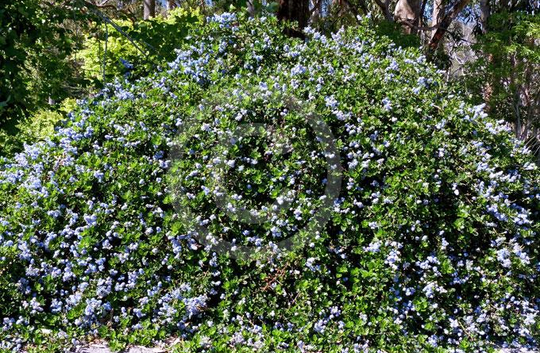
#15

Scientific Name: Ceanothus thyrsiflorus var. griseus 'Yankee Point'

Common Name: Yankee Point Carmel Ceanothus
Soil PH: 5.0 - 7.0
Height: 3 - 4 ft
Width: 10 - 12 ft
Sun/Shade Needs: Sun, Part Shade

Water Needs: Extremely Low Very Low Low Moderate-High
Attracts: Butterflies and bees
DESCRIPTION: This is one of the most commonly used California native plants. Yankee Point is a very garden tolerant spreading groundcover, with glossy green leaves and 1' blue flowers. On the coast it will take wind and salt spray, and it will do equally well inland. It is often used as a large-scale groundcover, and will stabilize slopes nicely. Can reach 2'-3' in height and spreads to 6'. Tolerates almost any soil type. Prefers sun in coastal sites, and sun or part shade in inland sites. Selection developed by Maunsell Van Rensselaer in 1954. Species previously known as C. griseus var. horizontalis.
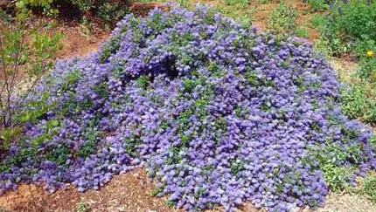
#16

Scientific Name: Ceanothus 'Joyce Coulter'

Common Name: Joyce Coulter Mountain Lilac
Height: 2 - 3 ft
Width: 10 - 12 ft
Sun/Shade Needs: Sun, Part Shade
Water Needs: Extremely Low Very Low Low Moderate-High
Attracts: Butterflies and bees
DESCRIPTION: 'Joyce Coulter' has dark green foliage and medium blue flowers which bloom all the way from March to May. This variety will tolerate pruning and a wide range of garden conditions. It is fast-growing and is a beautiful choice for large slopes, or above a retaining wall, or anywhere you want a low-water yet lush flowering plant. Due to it’s width, you can cover large areas with just a few plants. It grows well in hot areas and is drought tolerant.
Tolerates almost any soil type. Prefers sun in coastal sites, and sun or part shade in inland sites.

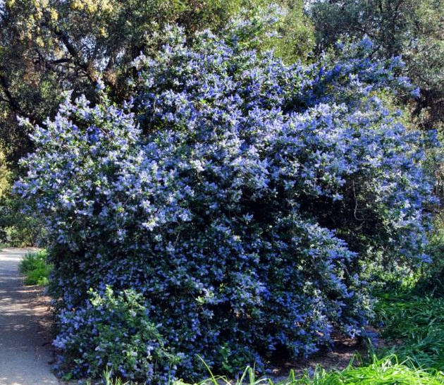
#17

Scientific Name: Ceanothus 'Ray Hartman'

Common Name: Ray Hartman Ceanothus
Soil PH: 6.0 - 8.0
Height: 15 - 30 ft
Width: 5 - 10 ft
Sun/Shade Needs: Sun, Part Shade
Water Needs: Extremely Low Very Low Low Moderate-High
Attracts: Butterflies and bees
DESCRIPTION: Ray Hartman Ceanothus is one of the easiest to grow of all the Ceanothus cultivars in California. It has dark green glossy leaves and blue flowers that range from powder blue to dark blue. It tolerates fairly dry soil and naturalizes well in areas with just a little more than average soil moisture during the dry season, such as slope bottoms and north facing slopes. It also tolerates supplemental irrigation up to once per week, though it is still better not to water directly during the summer or early fall once established. It will get all the water it needs as it stretches it's roots out to nearby irrigated areas.
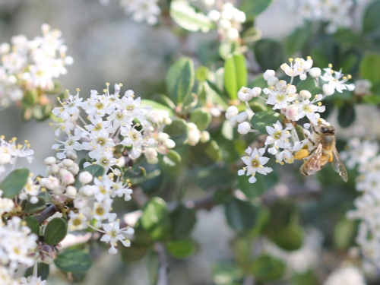
#20
Scientific Name: Ceanothus Cuneatus

Common Name: Buck Brush
Soil PH: 4.0 – 8.0
Height: 5 – 15 ft
Width: 5 – 12 ft

Sun/Shade Needs: Full Sun
Water Needs: Extremely Low Very Low Low Moderate-High
Attracts: Bees, birds, butterflies, larva

DESCRIPTION: Buck Brush is a species of flowering shrub also known as Wedgeleaf Ceanothus. It is one of the most common and widespread native plants in California’s chaparral. The evergreen leaves are stiff, tough and fleshy, and may be slightly toothed along the edges. The bush flowers abundantly in short, bearing rounded bunches of tiny flowers, each about half a centimeter wide. The flowers are white, sometimes tinted strongly with blue or lavender. The fruit is round capsule with horns. It is about half a centimeter wide and contains three shiny dark seeds which are dispersed when the capsule explodes and propels them some distance. Fire is needed for germination.

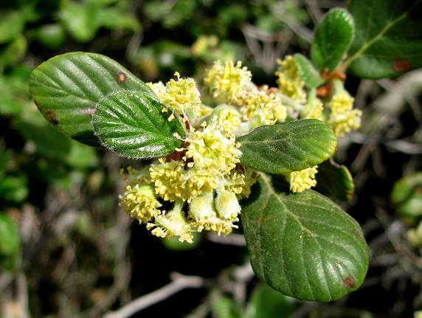
#22

Scientific Name: cercocarpus betuloides

Common Name: Mountain Mahogany
Height: 8 - 20 ft
Width: 10 - 12 ft
Sun/Shade Needs: Full Sun, Part Shade
Water Needs: Extremely Low Very Low Low Moderate-High
Attracts: Birds, butterflies and bees
DESCRIPTION: California Mountain Mahogany typically grows in dry areas in the foothills and mountains of California, often in chaparral communities, and in other parts of the southwestern United States and Baja California. This shrub has a typical size of three to five meters in height. The etymology of the species name derives from the Greek kerkos, from which the genus name root cerco derives, meaning "tail", referring to the tail-like appearance of the fruit; and carpus meaning "fruit": thus fruit with tail. Betula is the genus for birch, and the species name refers to the birch-like leaves. The leaves are distinctive in that they have smooth edges from the base to about half way up, then are wavy or toothed to the rounded tip. The shrub's white flowers are small, clustered, and mildly scented. The fruit is tubular, with a distinctive curly light thin feather-like extension going out 2 to 3 inches. The wood of the shrub is extremely hard and reddish, from which the incorrect common name comes. Native American Californians used the hard wood for arrows, digging and spearing fish.

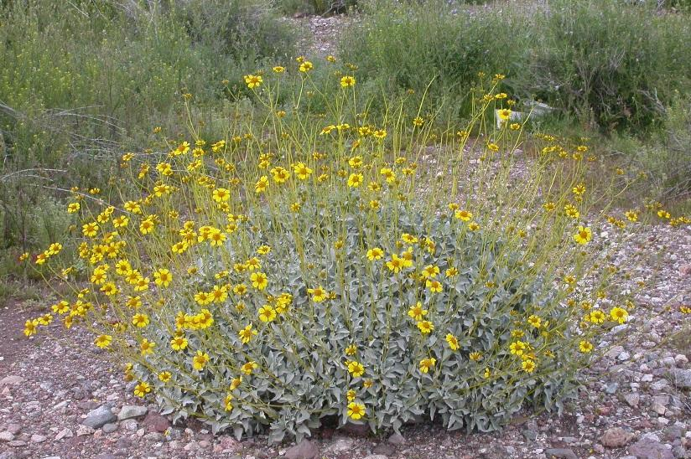
#25

Scientific Name: Encelia Farinosa

Common Name: Brittlebush
Height: 1 - 5 ft
Width: 4 ft
Sun/Shade Needs: Full sun
Water Needs: Extremely Low Very Low Low Moderate-High
Attracts: Desert birds and small mammals
DESCRIPTION: Brittlebush grows to 1 meter tall, with fragrant leaves 3-8 centimeters long. It can be found in a variety of desert habitats from dry gravelly slopes to open sandy washes up to 1000 meters. Has green-white grayish leaves and becomes covered with yellow daisy flowers. The flowers will attract butterflies and birds eat the seeds. The common name Incienso refers to the aromatic, resinous sap which can be used as an incense.

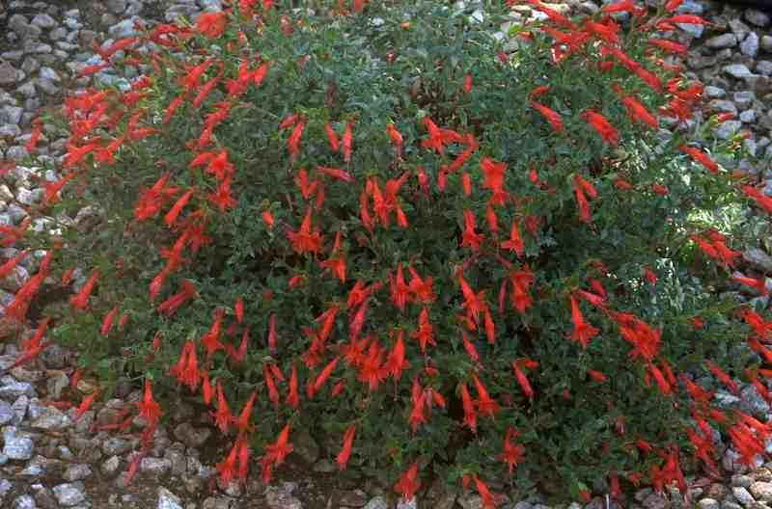
#26

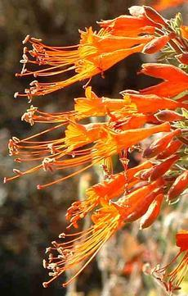
Scientific Name: Epilobium Californicum

Common Name: CA Fuschia
Height: 1 ft
Width: 4 ft
Sun/Shade Needs: Full sun
Water Needs: Extremely Low Very Low Low Moderate-High
Attracts: Hummingbirds
DESCRIPTION: When many native plants in the landscape are in summer dormancy, Epilobium blooms brightly with its orange-red tubular flowers held above grayish-green to green foliage. Epilobium’s brilliant color and tubular flower are guaranteed to attract hummingbirds, who take turns for the privilege of feeding on the nectar. In fact, Epilobium is dependent on hummingbirds for pollination, and it provides one of their principal nectar sources during the summer months.
Potentially could spread by underground rhizomes, and some will occasionally re-seed in the area. California Fuchsia performs beautifully in pots and baskets. For a slope, Epilobium is a great choice when planted with other natives that prefer full sun, little water and excellent drainage. After the first or second year, plants should be cut back almost to the ground. They should be pruned every year at the onset of the rainy season to encourage beautiful, fresh new growth for the following spring.

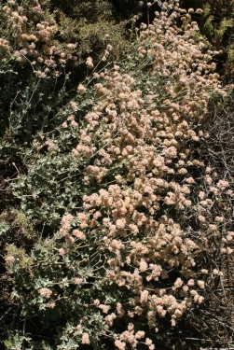
#27

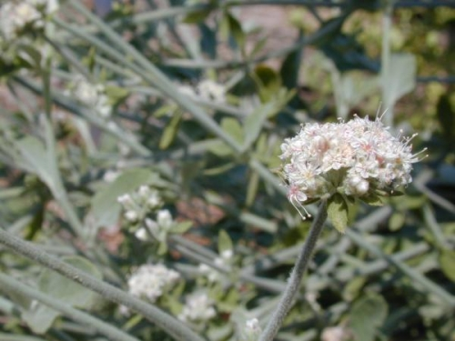
Scientific Name: Eriogonum Cinereum

Common Name: Ashy Leaf Buckwheat
Soil PH: 6.0 – 8.0
Height: 2 – 4 ft
Width: 3 – 5 ft

Sun/Shade Needs: Full Sun
Water Needs: Extremely Low Very Low Low Moderate-High
Attracts: Bees, birds, butterflies, larva

DESCRIPTION: Ashy Leaf Buckwheat is a species of wild buckwheat known by the common names coastal buckwheat and ashy leaf buckwheat. This shrub is endemic to the coastline of California, where it grows on beaches and bluffs and in coastal scrub and chaparral. This plant may reach up over a meter in height and width and is light silvery gray in color due to the woolly hairs on its stems and foliage. The leaves are wavy-edged ovals one to three centimeters long. The flower clusters stick out from the plant, each with one to several heads of tiny tightly-packed frilly flowers which are usually light brownish-pink in color and quite hairy.
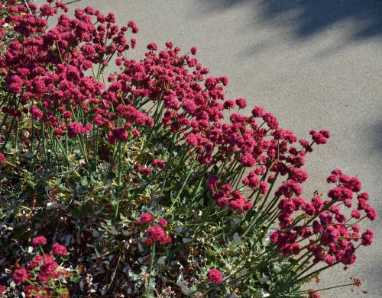
#29

Scientific Name: Eriogonum Grande var. Rubescens

Common Name: Ashy Leaf Buckwheat
Soil PH: 6.0 – 8.0
Height: .7 – 1.5 ft
Width: 3 – 3.5 ft

Sun/Shade Needs: Full Sun
Water Needs: Extremely Low Very Low Low Moderate-High
Attracts: Bees, birds, butterflies, larva

DESCRIPTION: Red Buckwheat is a rare native perennial herb. It is endemic to three of the northern Channel Islands but is now widely planted on the mainland. In the wild it tends to grow in dry cliffs, at elevations from 0-700 feet. It is a mat-forming plant producing tall, stout flower clusters of white, pink or red flowers. Its long bloom time in summer makes it popular with pollinators, especially butterflies. Leaves are located mainly at the base of the plant up to 10 cm long. It is useful in rock gardens, spilling over a wall, or in the understory of larger plants. Despite its island origin, it performs well inland if given some afternoon shade and a little extra water.

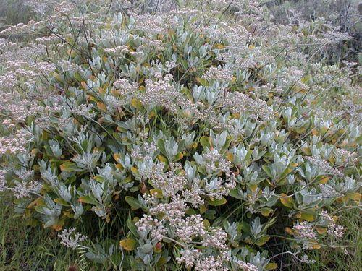
#30

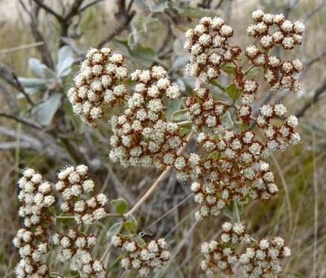
Scientific Name: Eriogonum Giganteum

Common Name: St Catherine’s Lace Buckwheat
Height: 1.6 - 5 ft
Width: 4 - 10 ft
Sun/Shade Needs: Full Sun
Water Needs: Extremely Low Very Low Low Moderate-High
Attracts: Butterflies, honey bees, native bees, birds and small mammals
DESCRIPTION: Planting in fast-draining, preferably rocky, soil and watering regularly until the plant is established gives St. Catherine's lace a good start. It grows quickly and adapts to inland temperatures higher than it's endemic range. It is clay tolerant when drainage is fast. Young flower heads are white and lacy, gradually turning to warm, reddish brown over the summer. Once flowers are dead-headed, the plant may look a bit sparse until warmer temperatures push out new white to soft gray-green leaves in abundance. The leathery, woolly, oval-shaped leaves are clustered sparsely along the mostly naked branches. The plant flowers densely in carpets of clustered tiny flowers, each hairy pinkish white flower only a few millimeters across.
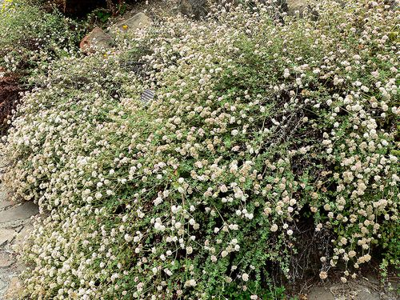
#31

Scientific Name: Eriogonum Parvifolium

Common Name: Coastal Buckwheat
Soil PH: 5.0 – 8.0
Height: 1 – 3.3 ft
Width: 2 – 3 ft

Sun/Shade Needs: Part Shade, Full Sun
Water Needs: Extremely Low Very Low Low Moderate-High
Attracts: Bees, birds, butterflies, larva

DESCRIPTION: Coastal Buckwheat occurs on dune formations and sea cliffs in the coastal area of Central and Southern California. This evergreen shrub grows to a height of 30 to 100 centimeters with a spread of approximately the same dimension. This plant is an important host for several pollinating insects including certain endangered species. E. parvifolium occurs both on bluffs along the Pacific Ocean coast as well as Coastal Strand dunes formations but is restricted to altitudes below 700 meters.
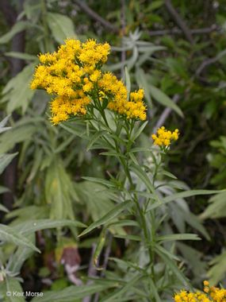
#32

Scientific Name: Euthamia Occidentalis

Common Name: Western Goldenrod
Soil PH: 5.0 – 8.0
Height: 3.5 – 7 ft
Width: 2 – 3 ft

Sun/Shade Needs: Full Sun
Water Needs: Extremely Low Very Low Low Moderate-High
Attracts: Butterflies, larva

DESCRIPTION: Western Goldenrod is a flowering plant known by the common names western goldentop and western goldenrod. It is a scrubby perennial plant with many green stems which age into a dull brownish-green, small leaves, and plentiful yellowish clusters of flowers. It is a common plant of western North America, where it is most likely to be found near water, such as ditches and marshes.

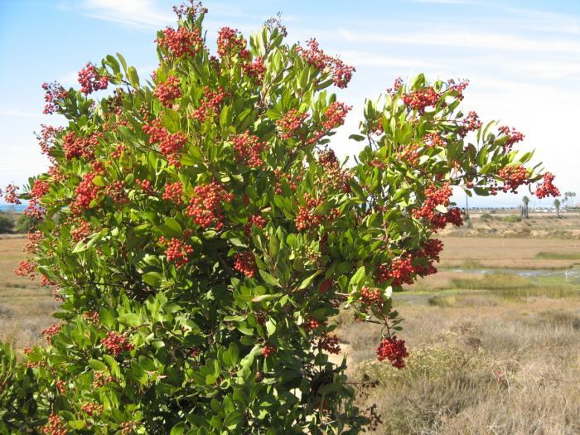
#33

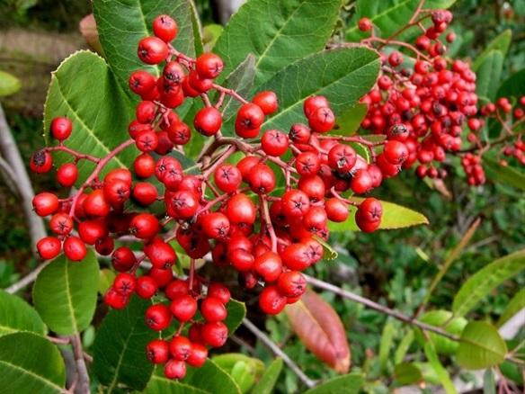
Scientific Name: Heteromeles arbutifolia

Common Name: Toyon
Height: 6 – 30 ft
Width: 10 – 15 ft
Sun/Shade Needs: Full sun, part shade
Water Needs: Extremely Low Very Low Low Moderate-High
Attracts: Bees are attracted to the flowers, birds love the berries
DESCRIPTION: Toyon are easy to grow. If properly situated, they can grow very quickly, up to 10 feet in three years. They like sun or part shade, though they tend to do better in part shade in the southern, drier part of their geographic range. They can handle a wide variety of soils, including clay, sand and serpentine, but need more moisture than most chaparral shrubs. They do well near seasonal creeks, seeps, bottom of slopes, or near irrigated areas. These plants tolerate a fair amount of summer water, up to 1x per week if the drainage is good. Toyon can be planted near houses since they are fire retardant when given enough moisture. They are an excellent hedge plant. In the early summer it produces small white flowers 6mm diameter in dense bunches, The fruit is small, bright red and berry-like, produced in large quantities, maturing in the fall and persisting well into the winter. The flowers are visited by butterflies and other insects, and have a mild, hawthorn-like scent. The berries are consumed by birds, including mockingbirds, American robins, and cedar waxwings. Mammals including coyotes and bears also eat and disperse the berries. Note that the berries contain a cianide compound that is toxic to humans.
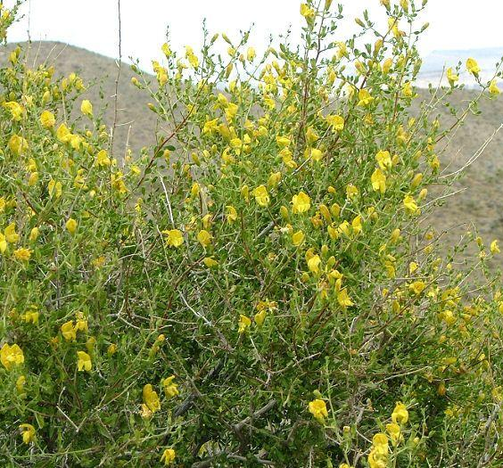
#34

Scientific Name: Keckiella Antirrhioides

Common Name: Yellow Bush Penstemon
Height: 1.6 – 6.6 ft
Width: 2 – 4 ft
Sun/Shade Needs: Full sun, part shade
Water Needs: Extremely Low Very Low Low Moderate-High
Attracts: Hummingbirds, butterflies and bees
DESCRIPTION: The oppositely-arranged leaves are up to 2 centimeters long and are lance-shaped or narrow ovals. They are deciduous during dry periods. The plant produces branchlike flower clusters which bear snapdragon-like flowers. Each hairy flower is about 2 centimeters wide, with three lower lobes which lie flat or curve down and two upper lobes which join to form a curved lip. Inside the flower are shiny filamentous stamens holding anthers and a flat, densely hairy sterile stamen called a staminode. The flowers are light yellow and dry to nearly black. The plant will often drop many leaves after flowering.

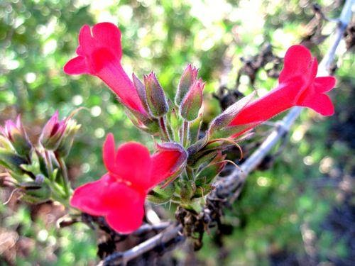
#35

Scientific Name: Gambelia speciose

Galvezia speciose “bocaboca”

Common Name: Boca Rosa Snapdragon
Height: 1 – 3 ft
Width: 10 ft
Sun/Shade Needs: Full Sun, part shade
Water Needs: Extremely Low Very Low Low Moderate-High
Attracts: Birds, especially hummingbirds and bees
DESCRIPTION: Island Snapdragon is easy to grow, fast growing and beautiful perennial. It has trumpet-shaped red flowers which attract birds, especially hummingbirds. Under the right conditions, it can bloom almost year-round. It prefers sun or part shade (more shade inland), but you will get more flowers in full sun. It likes rocky slopes and seaside conditions but will tolerate a variety of soils. Can tolerate occasional summer water, up to 2x per month. Good in containers.

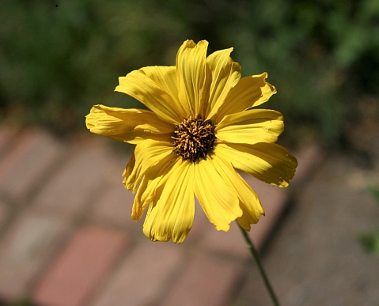
#36

Scientific Name: Encelia californica ‘el dorado’

Common Name: Bush Sunflower El Dorado Coast
Height: 3 - 4 ft
Width: 4 - 5 ft
Sun/Shade Needs: Full Sun
Water Needs: Extremely Low Very Low Low Moderate-High
Attracts: Birds, butterflies and bees
DESCRIPTION: California sunflower is a very easy and reliable shrub that will provide endless color in the landscape and is also good for cut flowers in the house. The large daisy-like flowers are a solid yellow with chocolate brown centers and are reminiscent of Black-Eyed Susan’s. The 'El Dorado' selection of this species has larger, more golden yellow flowers and blooms earlier in the season. The leaves are large and medium green. This is a fast growing 4' by 4' perennial that is very versatile. Use it on banks for erosion control or mixed with other natives for a colorful native perennial bed or mixed flower border. Cut the spent flowers for longer blooming and shaping. Blooms appear prolifically in spring but will also ap pear whenever there is some supplemental water and moderate temperatures. The flowers are a great favorite with butterflies, bees and other insects and the seed heads provide food for birds if the flowers are left to produce seed. Easy and tolerant of many garden conditions. Tolerates almost any soil type. Selected for the garden.

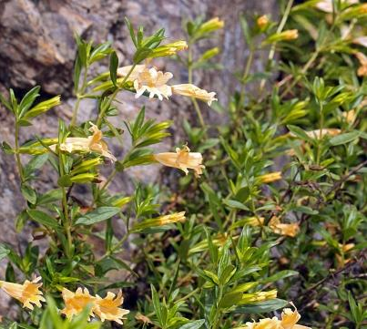
#37

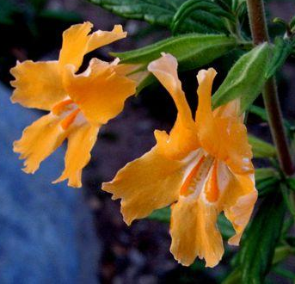
Scientific Name: Mimulus Aurantiacus

Common Name: Bush Monkeyflower
Height: 3.9 – 5 ft
Width: 5 ft
Sun/Shade Needs: Full sun, part shade
Water Needs: Extremely Low Very Low Low Moderate-High
Attracts: Hummingbirds and bees
DESCRIPTION: A flowering perennial plant that grows in a subshrub form with green sticky leaves. The flowers are tubular at the base and about 2 centimeters long with five broad lobes; they occur in a variety of shades from white to red, the most common color being a light orange. They are pollinated by bees and hummingbirds. The stigmas are notably sensitive and will close after being touched.

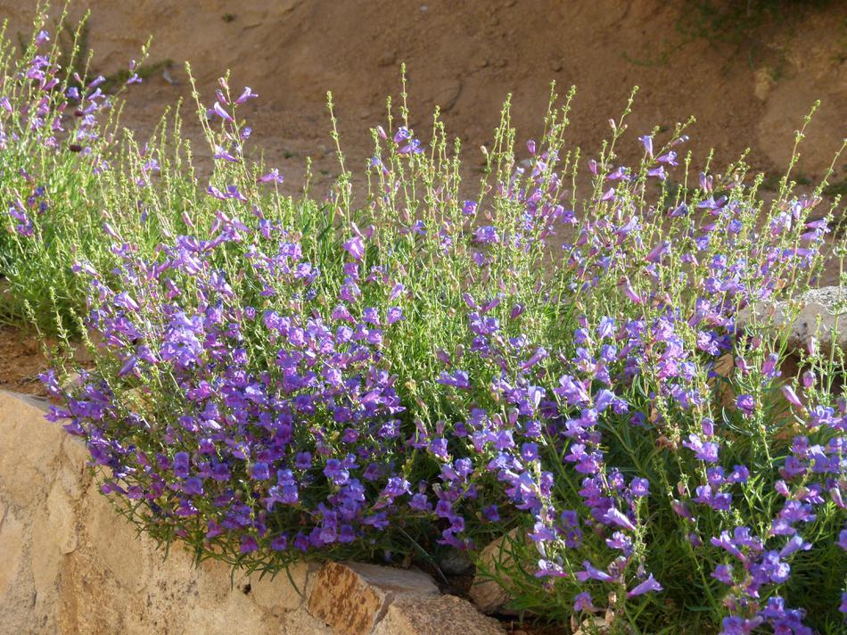
#40

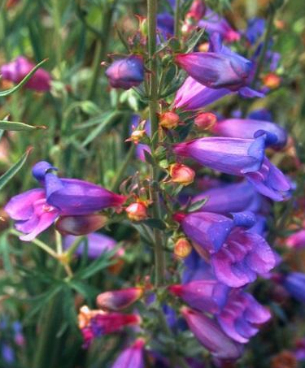
Scientific Name: Penstemon Heterophyllus ‘Marg Bop’

Common Name: Margarita Bob Penstemon
Height: 1 – 2 ft
Width: 2 – 3 ft
Sun/Shade Needs: Full sun, part shade
Water Needs: Extremely Low Very Low Low Moderate-High
Attracts: Hummingbirds and other birds
DESCRIPTION: This is a low growing penstemon with narrow, linear leaves and profuse blooms that start out blue and turn rose-purple. It gets to about 2' high and 2' wide and flowers from spring through the summer. It is highly desirable in the garden for its long-flowering and colorful blooms and is tolerant of a wide range of garden conditions. This flower works well in many situations; planted in masses on a bank, as part of a border, or in a rock garden.
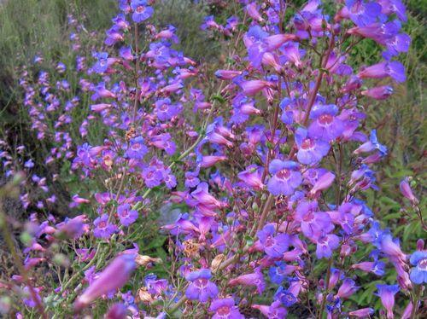
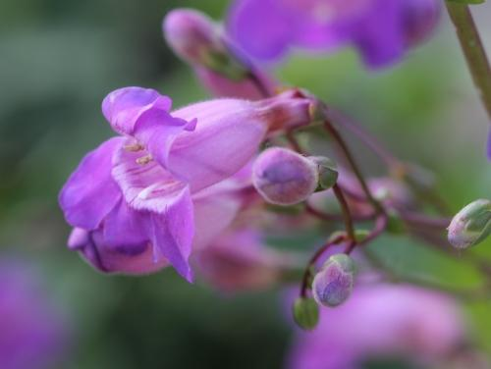
#41

Scientific Name: Penstemon Spectabilis

Common Name: Showy Penstemon
Height: 2 – 4 ft
Width: 3 – 4 ft
Sun/Shade Needs: Full sun
Water Needs: Extremely Low Very Low Low Moderate-High
Attracts: Hummingbirds and other birds
DESCRIPTION: Showy Penstemons are beautiful, fast growing, and easy to grow. Plants start producing spectacular hummingbird-attracting purple flowers their first year. They like full sun if planted in rocky, loamy or clay soils that hold moisture better, and part shade if planted in drier, sandier soils. It's best to plant on a slight slope or on flats that drain at least moderately well. They'll flower more abundantly with occasional summer water (1x per month), but may be shorter lived. If planted in an area that holds water better, like a flat with loamy or clay soil, or a slight slope with plenty of rocks, it's usually not necessary to give any supplementary summer water. Showy Penstemonts are fairly short lived even under the best of circumstances, typically lasting 5-10 years.
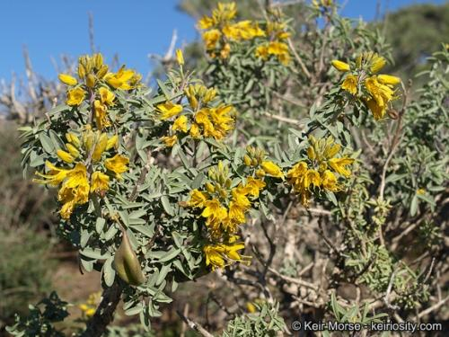
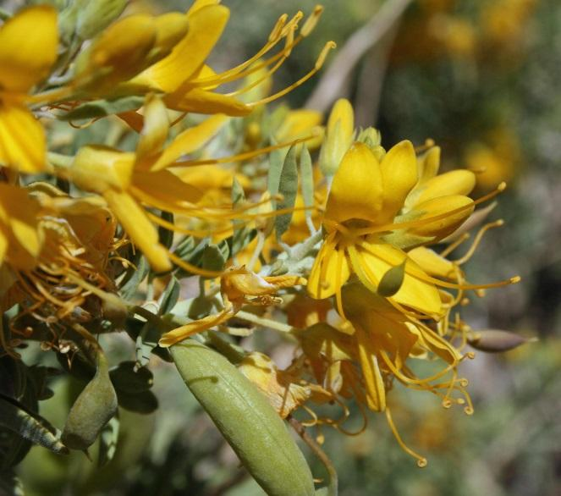
#42

Scientific Name: Peritoma Arborea

Common Name: Bladderpod
Height: 1.6 – 6.6 ft
Width: 6 ft
Sun/Shade Needs: Full sun
Water Needs: Extremely Low Very Low Low Moderate-High
Attracts: Bees, butterflies, hummingbirds and particularly attracts harlequin beetles, which eat the leaves
DESCRIPTION: Bladderpod is one of the easiest California natives to grow in landscape applications. It tolerates weekly summer water but can also get by with only natural rainfall. They are easy to grow from seeds, usually growing in a year to 3 feet tall. The readily self seed, and once you have a few mature plants in your garden, expect new seedlings to pop up each winter. This strong plant grows well even on south-facing slopes, alkaline soils and salty conditions. The flowers are beautiful, bright yellow, and stay on the plant most of the year, and attract bees, butterflies and hummingbirds. It is highly fragrant, though the public is divided on whether it is pleasant or unpleasant.
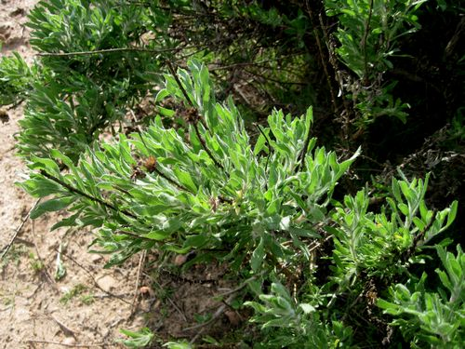
#43

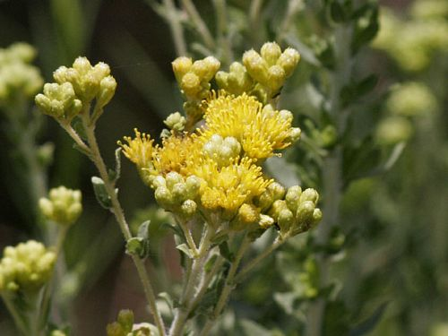
Scientific Name: Isocoma Menziesii

Common Name: Golden Bush
Soil PH: 6.0 – 7.5
Height: 1.6 – 3.3 ft
Width: 5 ft

Sun/Shade Needs: Full Sun, Part Shade
Water Needs: Extremely Low Very Low Low Moderate-High
Attracts: Bees, butterflies, larva

DESCRIPTION: Golden Bush is native to central and southern California and Baja and grows well particularly in sandy soils. This is a subshrub forming a matted bush reaching up to one meter tall. They vary in color from gray-green to reddish-brown. The leaves are oval-shaped to somewhat rectangular, gray-green and sometimes hairy, and 1 to 5 centimeters long. The abundant flowers are held in clusters of thick flower heads. The head is filled with large, protruding, cylindrical yellow disc florets with long stigmas. It is useful in restoration projects. Because of it very long bloom time it is a good choice for coastal gardens in the southern part of the state.
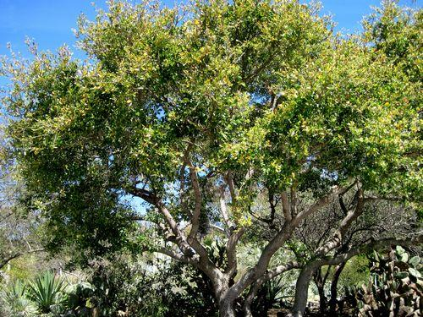
#46

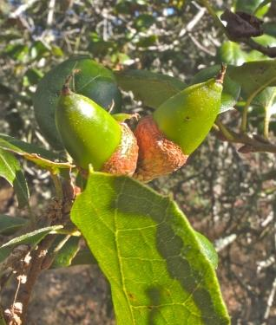
Scientific Name: Quercus Agrifolia

Common Name: Coast Live Oak
Height: 25 – 82 ft
Width: 15 – 35 ft
Sun/Shade Needs: Full sun, part shade
Water Needs: Extremely Low Very Low Low Moderate-High
Attracts: A great many birds, mammals, reptiles and invertebrates utilize oak trees and oak woodlands. Oaks are among the most important wildlife plants. The following butterflies use Oaks as host plant: California Sister, Propertius Duskywing, Mournful Duskywing, Golden Hairstreak, and Gold-Hunter's Hairstreak.
DESCRIPTION: Coast Live Oaks are fairly easy to grow. Water 1x per week the first year after planting, decreasing to about 1x per month after the first year, until the tree is about 10 feet tall. After that, it's best to avoid direct summer water entirely. In areas with less rainfall, best to plant Coast Live Oaks near an irrigated area. They'll get the water they need by stretching their roots out to the wetter area, but they'll keep the area close to their trunk nice and safely dry. Once they get their roots into the wetter areas, they'll grow rapidly and stay healthy looking all year round. Coast Live Oaks prefer to have their roots shaded, so it's a good idea to surround young specimens with mulch, rocks, or smaller native plants that won't crowd out the young tree trees but will provide shade to the roots. The best mulch is a thick layer of oak leaves. Don't fertilize oaks. They'll amend the soil over time with their own leaves and build the natural mycorrhizal fungus in the soil they need to thrive. Gradually, they become islands of natural fertility that improve the health of the nearby plants. The fruit is a slender reddish brown acorn 2-3.5 cm long.
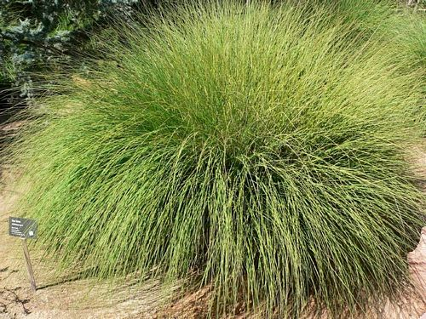
#47

Scientific Name: Muhlenbergia Rigens

Common Name: Deer Grass
Soil PH: 6.0 – 8
Height: 4 – 5 ft
Width: 5 – 10 ft

Sun/Shade Needs: Full Sun
Water Needs: Extremely Low Very Low Low Moderate-High
Attracts: Birds, butterflies, larva

DESCRIPTION: Deergrass is a large perennial bunchgrass found in sandy or well drained soils below 7000 feet in elevation in the southwest. It is characterized by dense, tufted foliage consisting of narrow pointed leaves range in color from light silver-green to purple. The spike-like stems are less than half an inch wide and 3 to 4 feet in length. During bloom, the numerous flower bunches often reach heights of five feet. It is one of the easiest to grow of all the native California bunchgrasses, typically reaching mature size in one or two years. It can handle fairly frequent summer water (up to 1x per week), but once mature, it really doesn't need any supplementary water.

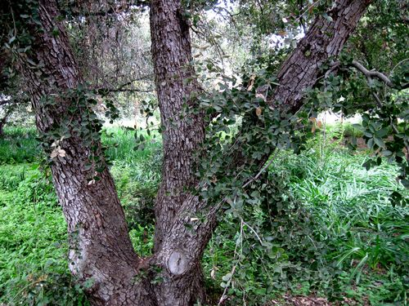
#48
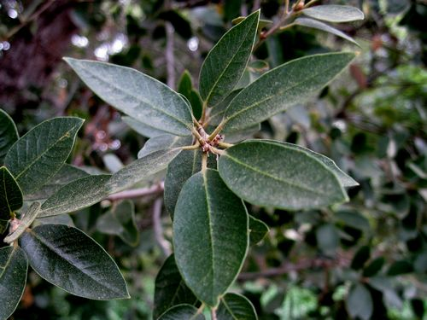
Scientific Name: Quercus Chrysolepsis

Common Name: Canyon Live Oak
Soil PH: 5.0 – 8.0
Height: 30 – 90 ft
Width: 30 - 60 ft

Sun/Shade Needs: Full Sun, Part Shade, Shade
Water Needs: Extremely Low Very Low Low Moderate-High
Attracts: Birds, butterflies, larva

DESCRIPTION: Canyon live oak is a species of evergreen oak that is found in the southwestern part of North America, notably in the California Coast Ranges. It is the most wide-spread oak in the state. Its ultimate size and shade are determined by its location within the state. This tree is often found near creeks and drainage swales growing in moist cool microhabitats. Its leaves are a glossy dark green on the upper surface with prominent spines; a further rapid identification arises from the leaves of Canyon live oak being geometrically flat. They live well with several other oak species.

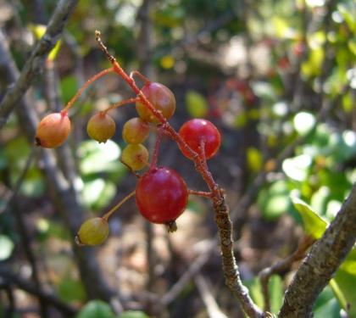
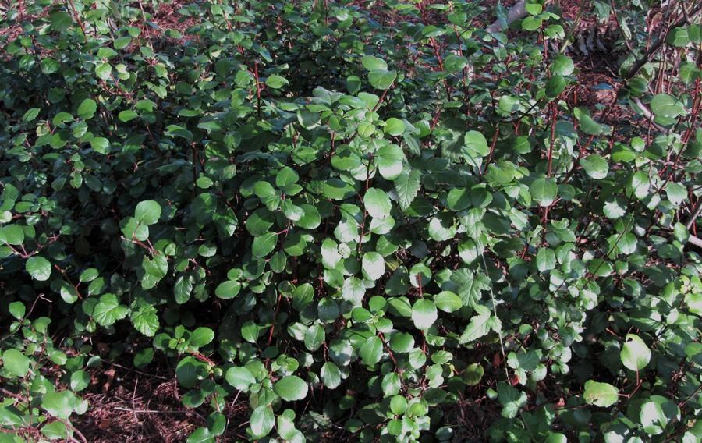
#50

Scientific Name: Ribes Vibunifolium

Common Name: Evergreen Currant
Height: 2 – 3 ft
Width: 8 ft
Sun/Shade Needs: Part shade
Water Needs: Extremely Low Very Low Low Moderate-High
Attracts: Hummingbirds, small mammals and other birds
DESCRIPTION: Shrub. The leaves are dark green and shiny on their top surfaces, and lighter green or yellowish and leathery on the undersides. The leaves have glands which exude a sticky, citrus-scented sap. Clusters of deep red flowers bloom in late winter and into early spring. The plant yields small red fruits later in the spring that attract birds.

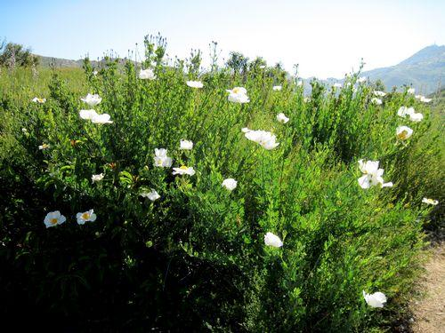
#51

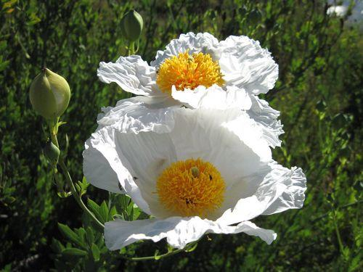
Scientific Name: Romneya Coulteri

Common Name: Matilija Poppy
Height: 6.6 – 10 ft
Width: 20 ft
Sun/Shade Needs: Full sun
Water Needs: Extremely Low Very Low Low Moderate-High
Attracts: Butterflies and bees
DESCRIPTION: It is summer deciduous and winter dormant, so patience is required to get it established. Once established, it spreads aggressively and may need to be controlled to prevent undesired expansion. Pulling shoots is usually effective. The gray-green, waxy-textured leaves are each divided into a few lance-shaped lobes, the blades growing up to 20 centimeters long. The inflorescence is a large, solitary flower with six crinkly white petals each up to 10 centimeters long. At the center of the flower is a cluster of many yellow stamens.

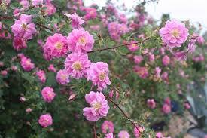
#52

Scientific Name: Rosa Californica

Common Name: CA Wild Rose
Height: 8 – 10 ft
Width: 10 ft
Sun/Shade Needs: Full sun, part shade, full shade
Water Needs: Extremely Low Very Low Low Moderate-High
Attracts: Bees, butterflies and birds
DESCRIPTION: It is a deciduous thicket-forming shrub with prickly, curving stems. Each rose is open-faced and generally flat, with five petals in any shade of pink from almost white to deep magenta. The fragrant flowers may grow singly or in flower clusters of several blooms. It produces typical rose hips containing yellow seeds. The plant is native to arid regions and can survive drought, but it grows most abundantly in moist soils near water sources. It is most often used as a barrier planting in a garden where it can be allowed to form a large thicket. It can go summer dormant (or partially) if it doesn't get enough water.
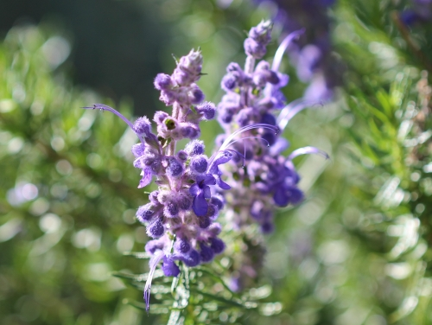
#53

Scientific Name: Trichostema Lanatum

Common Name: Wooly Blue Curls
Soil PH: 6 – 7.5
Height: 3 – 5 ft
Width: 4 - 5 ft

Sun/Shade Needs: Full Sun, Part Shade
Water Needs: Extremely Low Very Low Low Moderate-High
Attracts: Birds, bees, butterflies, larva

DESCRIPTION: Woolly Blue Curls is a highly fragrant, small evergreen shrub, with curly and woolly blue flowers that give the plant its common name. It is native to oak woodlands, chaparral and coastal sage scrub communities. The smooth-petaled blue flowers are born in dense clusters, covered in woolly hairs of blue, pink, or white. Hummingbirds are very attracted to the flowers. In landscaping applications, they need regular water their first year to become established. After that, even occasional summer water will sometimes kill it. If properly sited, it will usually tolerate light or indirect summer water up to 1x per month. They need very well-draining soil.
#55

Scientific Name: Salvia ‘Bee’s Bliss’

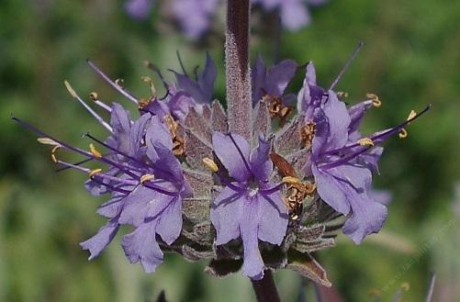
Common Name: Bee’s Bliss Sage
Height: 1 – 2 ft
Width: 2 – 5 ft
Sun/Shade Needs: Full sun
Water Needs: Extremely Low Very Low Low Moderate-High
Attracts: hummingbirds, bees and various other birds
DESCRIPTION: This cross of Salvia clevelandii with Salvia leucophylla produced a beautiful and compact hybrid, one that can fill a quaint corner of any landscape. This 1' to 2' mounding sage originated from the UC Botanical Garden and has developed an enthusiastic following. As the name suggests,'Bee's Bliss' is attractive to pollinators who visit its lavender-pink flowers.

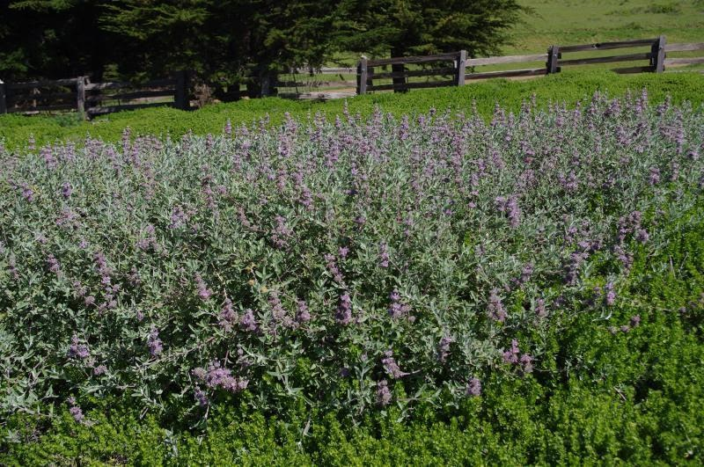
#58

Scientific Name: Salvia Leucophylla

Common Name: Purple sage
Height: 1 – 2 ft
Width: 6 – 8 ft
Sun/Shade Needs: Sun, part shade
Water Needs: Extremely Low Very Low Low Moderate-High
Attracts: Butterflies, bees and various birds
DESCRIPTION: This low-growing groundcover is a perfect selection for full-sun or part-shade areas. This variety is a grayish-green leaved, multi-blossomed salvia hybrid that exibits low water needs and has little demand in terms of maintenance. The flowers can be pruned in late fall to produce a good flush in the spring. The lavender flowers are arranged in a circular pattern around the green stems. The flowers attract butterflies, bees, and hummingbirds. Tolerates almost any soil type. Prefers sun in coastal sites, and sun or part shade in inland sites.

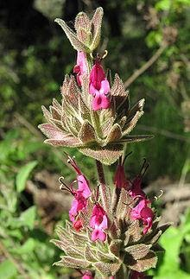
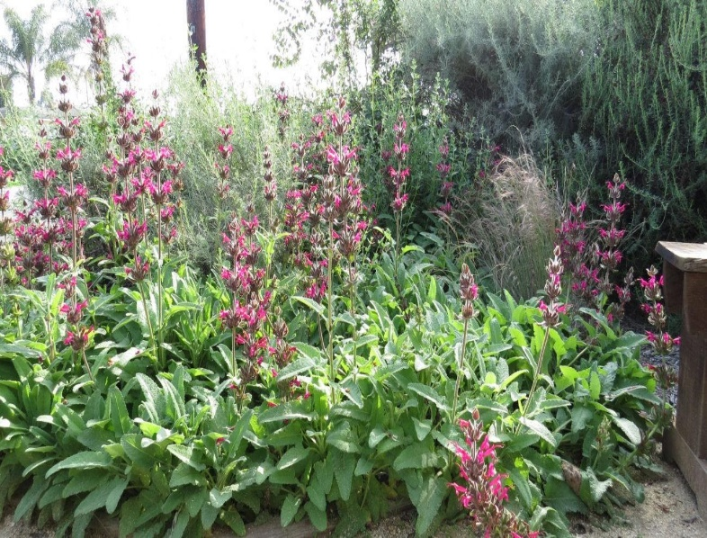
#61

Scientific Name: Salvia Spathacea

Common Name: Hummingbird Sage
Height: 1 – 3 ft
Width: 3 ft
Sun/Shade Needs: Part Shade, full shade
Water Needs: Extremely Low Very Low Low Moderate-High
Attracts: Hummingbirds, Butterflies, bees and various other birds
DESCRIPTION: Plant Hummingbird Sage in dry shaded or partly shaded areas. It seems to do best in full shade, under oak trees and other dense foliage. Hummingbird Sage is very drought tolerant, and after the first year, can usually make it through the summer without any supplementary water, though it tends to go semi-deciduous without occasional irrigation. If you want it to be green year-round, it'll tolerate summer water once or twice a month. When not flowering, plants grow less than.5 meter (4 to 12 inches) tall forming clumps of sprawling foliage. Unlike most sages, the flowering stems are produced singularly from each plant and only rarely branch. It spreads by rhizomes and can form colonies. Like many species in the mint family it has very pronounced square stems, and the entire plant is covered with wavy glandular hairs. Its bright green leaves are highly aromatic when crushed or touched. They are oblong to almost arrowhead-shaped at the base, and can be puckered with wrinkles, and have rounded teeth at the leaf edges. Like the rest of the plant, they are covered with hairs which make the plant soft to the touch. The hairs tend to be denser on the bottom surface of the leaves. The dark red flowers are produced in clustered whorled inflorescence on spike-like stems with each node on the top half of the stem having flowers.

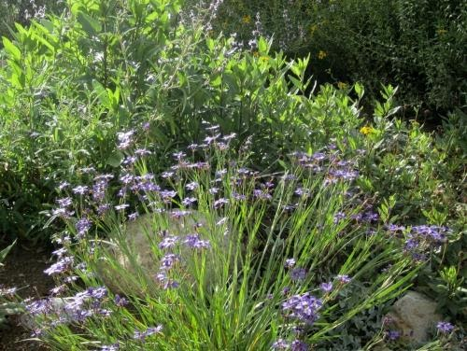
#63

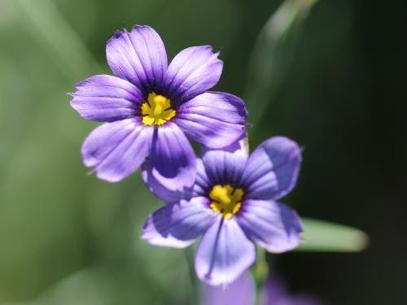
Scientific Name: Sisyrinchium Bellum

Common Name: Blue-Eyed Grass
Height: 1 – 2 ft
Width: 1 ft
Sun/Shade Needs: Sun, part shade
Water Needs: Extremely Low Very Low Low Moderate-High
Attracts: Bees
DESCRIPTION: The flowers are small and purplish-blue, varying somewhat in color from a true blue to a definite purple; occasional white-flowering plants are found. It flowers from January to July. After flowering, it dies back to the ground and is dormant over the summer. It prefers some moisture and good drainage, but will tolerate summer dryness. It can be propagated by seed, and self-sows. It can also be propagated by division of its rhizomes, and the flower stems can be rooted.
Blue eyed grass is very easy to grow and will easily reseed. Best to plant on flat areas, loamy soils that that hold moisture well. Even though it goes dormant in the summer, in dryer, southern areas, Blue eyed grass is more likely to survive the summer drought with occasional watering.

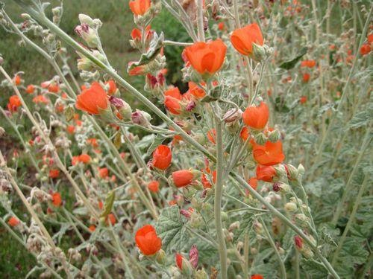
#65

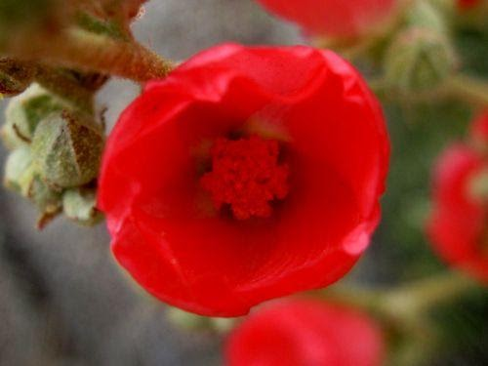
Scientific Name: Sphaeralcea Ambigua

Common Name: Desert Mallow
Height: 3 – 5 ft
Width: 2 – 4 ft
Sun/Shade Needs: Full sun
Water Needs: Extremely Low Very Low Low Moderate-High
Attracts: Butterflies, bees and birds
DESCRIPTION: Grows well in alkaline soil, both sandy or clay, usually in the company of creosote bush scrub and desert chaparral habitats. The Sphaeralcea ambigua plant grows to 3 feet in height, and spreads to 2-4 feet in width. The leaves are fuzzy with white hairs on both sides, lobed, veined, and on long stems, the number of which increase with age. The fruit is a brown capsule containing numerous seeds, first quite spherical as implied by the genus name, later flattening to a disk. The flowers are bowl-shaped, 5-petaled, apricot to dark orange red in color, and bloom in the spring.

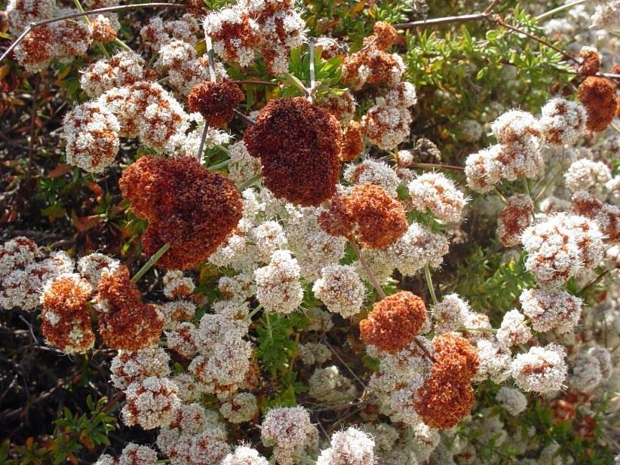
#68

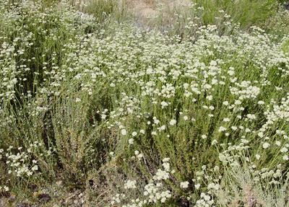
Scientific Name: Erigonum Fasciculatium

Common Name: Warriner Lytle Buckwheat
Height: 2 – 6.6 ft
Width: 3 ft
Sun/Shade Needs: Full sun
Water Needs: Extremely Low Very Low Low Moderate-High
Attracts: Butterflies and bees
DESCRIPTION: California Buckwheats are strong and easy to grow, even in very dry conditions. Plant in a well-draining sunny site. It shouldn't need supplemental water after established, but it will tolerate occasional summer water better than most extremely drought tolerant California natives. Form is variable, ranging from often open and upright in the foothills, to often dense and mounding closer to the coast. It produces profuse pink to white and cream-colored flowers as early as March that dry to a pretty red rust color as the soil dries. It sheds its dried flowers and a significant portion of its small blade-like leaves each dry season, and is an important plant for creating natural mulch. California Buckwheat is a keystone species for sagebrush scrub ecosystems, and a great choice for wildlife and butterfly gardens.

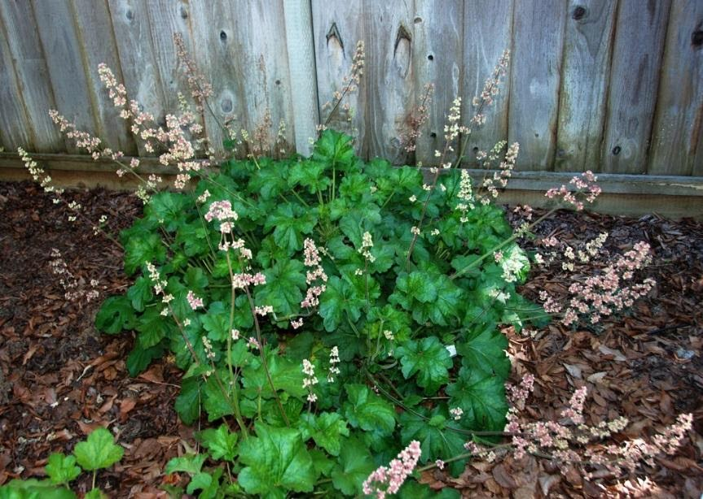
#69

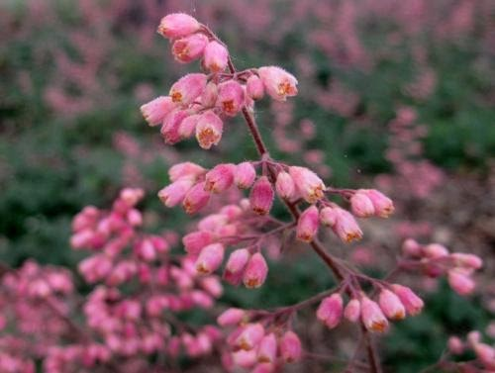
Scientific Name: Heuchera Maxima

Common Name: Island Alum Root
Height: 1 – 2 ft
Width: 2 ft
Sun/Shade Needs: Sun, part shade or full shade
Water Needs: Extremely Low Very Low Low Moderate-High
Attracts: Hummingbirds
DESCRIPTION: It is also cultivated as an attractive garden plant, valued for both its foliage and flowers. This is a rhizomatous perennial herb growing a broad patch of large, rounded, multi-lobed green leaves with long leaf stalks and a fringe of hairs along the edges. It produces an erect flower cluster up to 60 centimeters tall with many clusters of tiny, hairy flowers. Each flower is rounded with fleshy white or pink lobes and tiny petals curling away from the center. The protruding stamens are tipped with large anthers.
It performs best in coastal gardens where it can take full sun to part shade. In inland gardens it may require full shade and additional water. It looks good in woodland gardens.

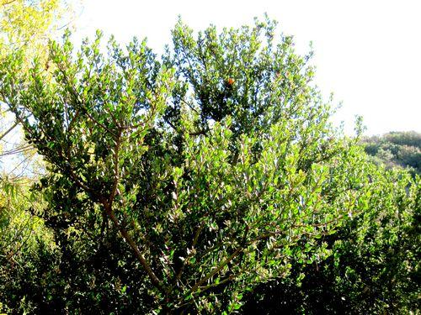
#74

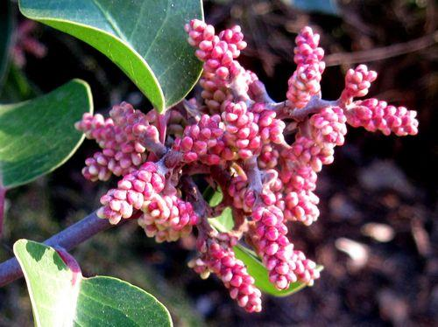
Scientific Name: Rhus Ovata

Common Name: Sugarbush
Height: 6.6 – 32 ft
Width: 30 ft
Sun/Shade Needs: Full sun, part shade
Water Needs: Extremely Low Very Low Low Moderate-High
Attracts: Birds
DESCRIPTION: Sugarbush is resilient and easy to grow, and very fast growing once established. A 5 gallon container plant will reach 10 feet in about 3 years if happy. In nature, you'll almost always see Sugar Bush on slopes, though it grows well on flat areas in garden applications. It's one of the few larger chaparral shrubs that grows well in south facing slopes even in the drier parts of it's range, and is a great bank stabilizer. It tolerates a wide variety of soils. It grows fastest with full sun, and just a little slower in part shade. It tolerates summer water up to 1x per month, but shouldn't need any once established. The plants are incredibly healthy, and typically will appear green and lush through the entire dry season without any supplementary water. The biggest downside of this plant is that it can get huge, often more than 30 feet wide, and can aggressively crowd out nearby plants. It is said to be fire resistant, especially if given supplemental water.

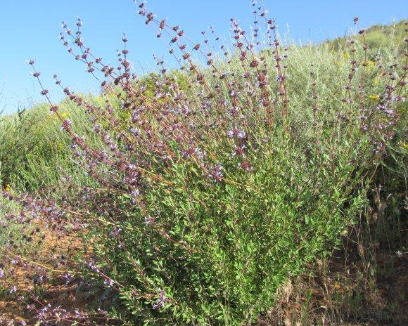
#60

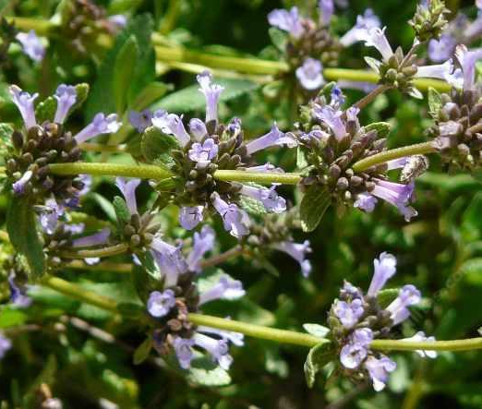
Scientific Name: Salvia Munzii

Common Name: San Miguel Mountain Sage
Height: 1.5 – 3 ft
Width: 3 ft
Sun/Shade Needs: Full sun
Water Needs: Extremely Low Very Low Low Moderate-High
Attracts: Butterflies, bees and various other birds
DESCRIPTION: It grows at elevations from 500-3000 feet, usually in very dry conditions. It is a compact sage that works well in a container or small space. Though it is very drought tolerant, it accepts summer water well. Loved by all pollinators.

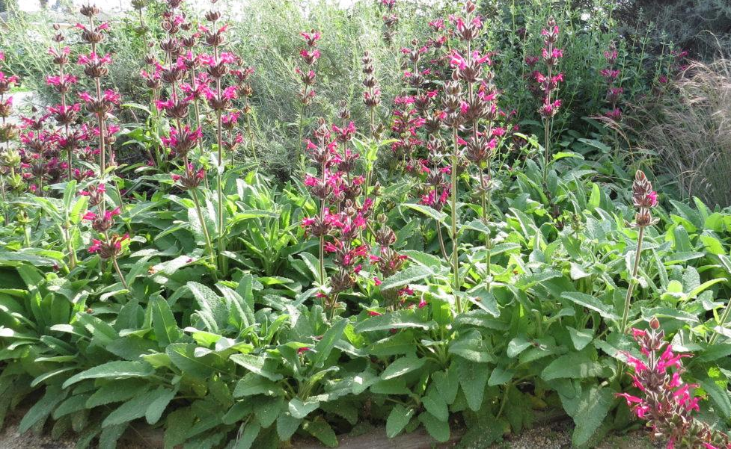
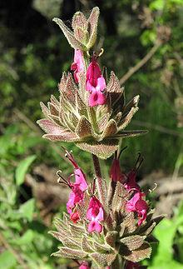
#61

Scientific Name: Salvia Spathacea

Common Name: Hummingbird Sage
Height: 1 – 3 ft
Width: 3 ft
Sun/Shade Needs: Part Shade, full shade
Water Needs: Extremely Low Very Low Low Moderate-High
Attracts: Hummingbirds, Butterflies, bees and various other birds
DESCRIPTION: Plant Hummingbird Sage in dry shaded or partly shaded areas. It seems to do best in full shade, under oak trees and other dense foliage. Hummingbird Sage is very drought tolerant, and after the first year, can usually make it through the summer without any supplementary water, though it tends to go semi-deciduous without occasional irrigation. If you want it to be green year round, it'll tolerate summer water once or twice a month. When not flowering, plants grow less than.5 meter (4 to 12 inches) tall forming clumps of sprawling foliage. Unlike most sages, the flowering stems are produced singularly from each plant and only rarely branch. It spreads by rhizomes and can form colonies. Like many species in the mint family it has very pronounced square stems, and the entire plant is covered with wavy glandular hairs. Its bright green leaves are highly aromatic when crushed or touched. They are oblong to almost arrowhead-shaped at the base, and can be puckered with wrinkles, and have rounded teeth at the leaf edges. Like the rest of the plant, they are covered with hairs which make the plant soft to the touch. The hairs tend to be denser on the bottom surface of the leaves. The dark red flowers are produced in clustered whorled inflorescence on spike-like stems with each node on the top half of the stem having flowers.
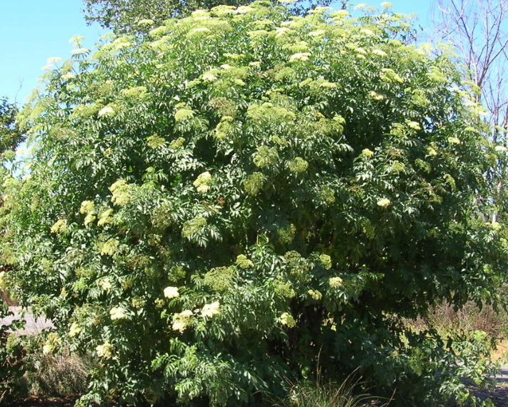
#62

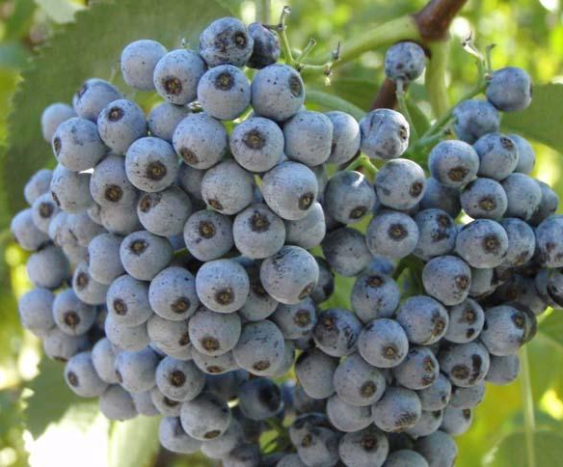
Scientific Name: Sambucus Mexicana

Common Name: Mexican Elderberry
Height: 20 – 30 ft
Width: 20 – 30 ft
Sun/Shade Needs: Part shade/sun, full shade
Water Needs: Extremely Low Very Low Low Moderate-High
Attracts: Many various birds
DESCRIPTION: Blue Elderberry is strong, easy to grow, and grows very rapidly. It can grow from a 1 gallon container to a 15 foot tree in 3 years if happy. It handles a variety of different soil moisture levels once established. It can handle permanently moist soil near stream sides or seeps, and will thrive next to or in regularly irrigated areas. Once established, it also grows well in fairly dry soils, though in drier conditions it will normally go deciduous or semi-deciduous in the summer and fall, and green up in the early winter. Drought-stressed Blue Elderberry's often end up more attractive than ones that get plenty of year round water, frequently developing interesting gnarled branches and thicker though shorter trunks over time. Likes part shade or sun, and will tolerate full shade, though in full shade it will look rangy as its branches search out for more sun.
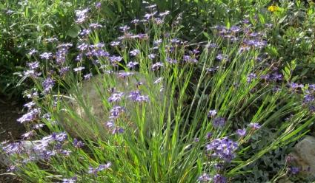
#63

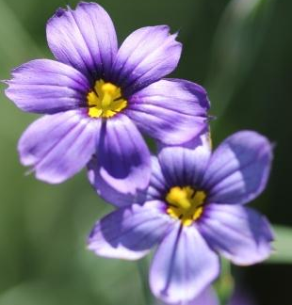
Scientific Name: Sisyrinchium Bellum

Common Name: Blue-Eyed Grass
Height: 1 – 2 ft
Width: 1 ft
Sun/Shade Needs: Sun, part shade
Water Needs: Extremely Low Very Low Low Moderate-High
Attracts: Bees
DESCRIPTION: The flowers are small and purplish-blue, varying somewhat in color from a true blue to a definite purple; occasional white-flowering plants are found. It flowers from January to July. After flowering, it dies back to the ground and is dormant over the summer. It prefers some moisture and good drainage, but will tolerate summer dryness. It can be propagated by seed, and self-sows. It can also be propagated by division of its rhizomes, and the flower stems can be rooted.
Blue eyed grass is very easy to grow and will easily reseed. Best to plant on flat areas, loamy soils that that hold moisture well. Even though it goes dormant in the summer, in dryer, southern areas, Blue eyed grass is more likely to survive the summer drought with occasional watering.

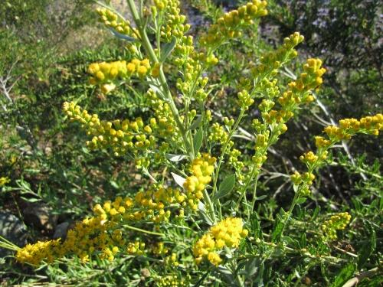
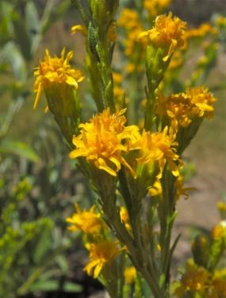
#64

Scientific Name: Solidago Velutina ssp Californica

Common Name: CA Goldenrod
Height: 1.5 - 5ft
Width: 3 – 5 ft
Sun/Shade Needs: Sun, part shade, full shade
Water Needs: Extremely Low Very Low Low Moderate-High
Attracts: Bees
DESCRIPTION: It produces masses of yellow flowers when many other plants are dormant. Birds and pollinating insects love this plant. Grows well in central oak woodlands. It likes to be wet in winter/spring and dry in summer but can take extra water. It is a spreader from a creeping rootstock and may become invasive, so plant it where it will have plenty of room. Otherwise it is very garden tolerant and easy.

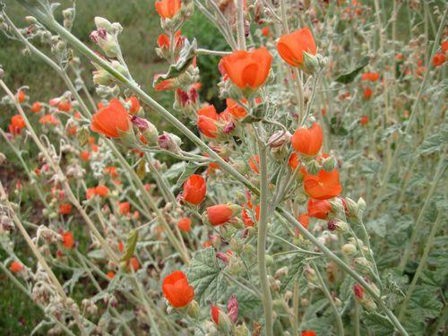
#65

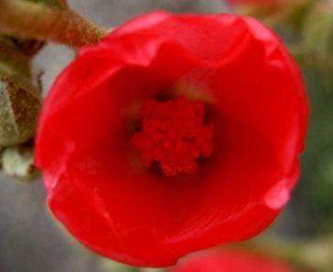
Scientific Name: Sphaeralcea Ambigua

Common Name: Desert Mallow
Height: 3 – 5 ft
Width: 2 – 4 ft
Sun/Shade Needs: Full sun
Water Needs: Extremely Low Very Low Low Moderate-High
Attracts: Butterflies, bees and birds
DESCRIPTION: Grows well in alkaline soil, both sandy or clay, usually in the company of creosote bush scrub and desert chaparral habitats. The Sphaeralcea ambigua plant grows to 3 feet in height, and spreads to 2-4 feet in width. The leaves are fuzzy with white hairs on both sides, lobed, veined, and on long stems, the number of which increase with age. The fruit is a brown capsule containing numerous seeds, first quite spherical as implied by the genus name, later flattening to a disk. The flowers are bowl-shaped, 5-petaled, apricot to dark orange red in color, and bloom in the spring.

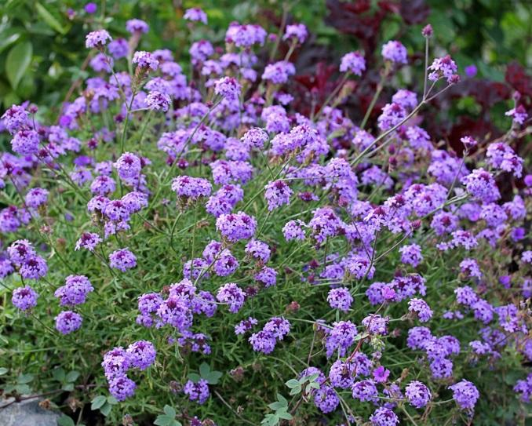
#66

Scientific Name: Verbena Lilacina ‘de la mina’

Common Name: Cedros Island Verbena
Height: 2 – 3 ft
Width: 3 – 4 ft
Sun/Shade Needs: Full sun, part shade
Water Needs: Extremely Low Very Low Low Moderate-High
Attracts: Butterflies and bees
DESCRIPTION: Produces mounds of delicate green foliage and has dark purple blossoms with lavender streaks and the blossoms are lightly scented. Though there are more flowers in the spring, this plant has blossoms throughout most of the year which attracts butterflies throughout the year. This small shrub grows to about 2' high and spreads to about 4'. It does best in well drained soils but will tolerate clay soil provided it isn't over-watered. This is a very attractive and versatile plant for any flower border, butterfly garden or plant it in containers on a patio. To maintain a dense form shear lightly in summer, and remove spent flowers. The butterflies will flock to your garden!
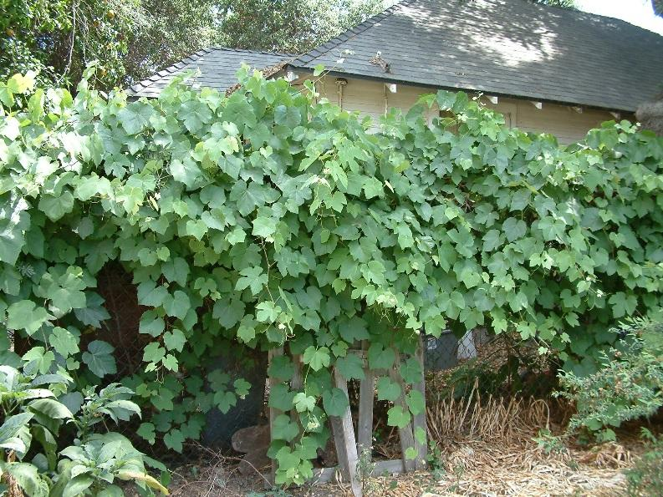
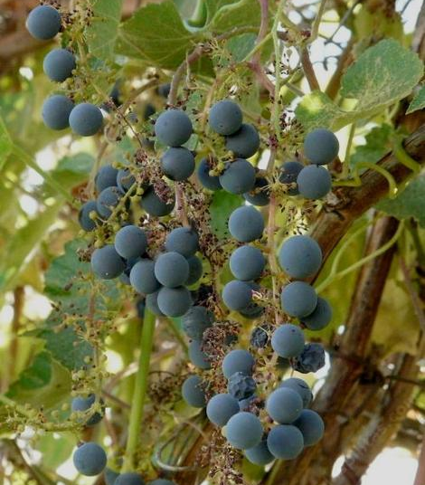
#67

Scientific Name: Vitis Californica

Common Name: Native CA Grape
Height: 10 – 40 ft
Width: 1 ft
Sun/Shade Needs: Full sun, part shade
Water Needs: Extremely Low Very Low Low Moderate-High
Attracts: Many various birds, bees, butterflies and mammals
DESCRIPTION: A deciduous vine which can grow to over 30 feet in length. It climbs on other plants or covers the ground with twisted, woody ropes of vine covered in green leaves. In the fall the leaves turn many shades of orange and yellow, and bunches of small and often sour but edible purple grapes hang from the vines. It is a common sight along the banks of the Sacramento River. The California wild grape grows along streams and rivers and thrives in damp areas; however, like most other native California plants it can withstand periods of dry conditions. The grapes provide an important food source for a variety of wild animals, especially birds, and the foliage provides thick cover. Bees love the flowers, and it is one of the best plants for butterflies in fall.
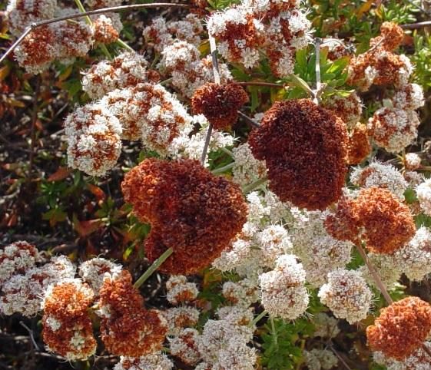
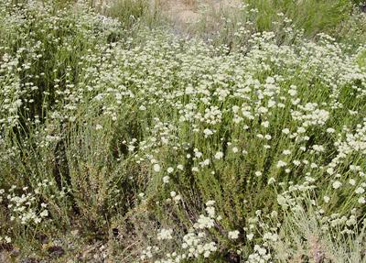
#68

Scientific Name: Erigonum Fasciculatium

Common Name: Warriner Lytle Buckwheat
Height: 2 – 6.6 ft
Width: 3 ft
Sun/Shade Needs: Full sun
Water Needs: Extremely Low Very Low Low Moderate-High
Attracts: Butterflies and bees
DESCRIPTION: California Buckwheats are strong and easy to grow, even in very dry conditions. Plant in a well-draining sunny site. It shouldn't need supplemental water after established, but it will tolerate occasional summer water better than most extremely drought tolerant California natives. Form is variable, ranging from often open and upright in the foothills, to often dense and mounding closer to the coast. It produces profuse pink to white and cream-colored flowers as early as March that dry to a pretty red rust color as the soil dries. It sheds its dried flowers and a significant portion of its small blade-like leaves each dry season, and is an important plant for creating natural mulch. California Buckwheat is a keystone species for sagebrush scrub ecosystems, and a great choice for wildlife and butterfly gardens.

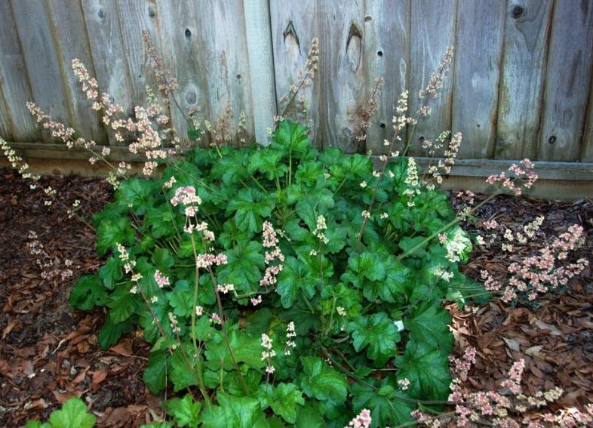
#69

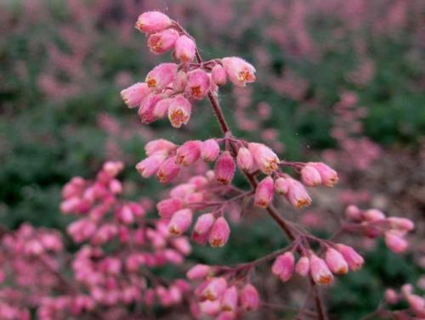
Scientific Name: Heuchera Maxima

Common Name: Island Alum Root
Height: 1 – 2 ft
Width: 2 ft
Sun/Shade Needs: Sun, part shade or full shade
Water Needs: Extremely Low Very Low Low Moderate-High
Attracts: Hummingbirds
DESCRIPTION: It is also cultivated as an attractive garden plant, valued for both its foliage and flowers. This is a rhizomatous perennial herb growing a broad patch of large, rounded, multi-lobed green leaves with long leaf stalks and a fringe of hairs along the edges. It produces an erect flower cluster up to 60 centimeters tall with many clusters of tiny, hairy flowers. Each flower is rounded with fleshy white or pink lobes and tiny petals curling away from the center. The protruding stamens are tipped with large anthers.
It performs best in coastal gardens where it can take full sun to part shade. In inland gardens it may require full shade and additional water. It looks good in woodland gardens.
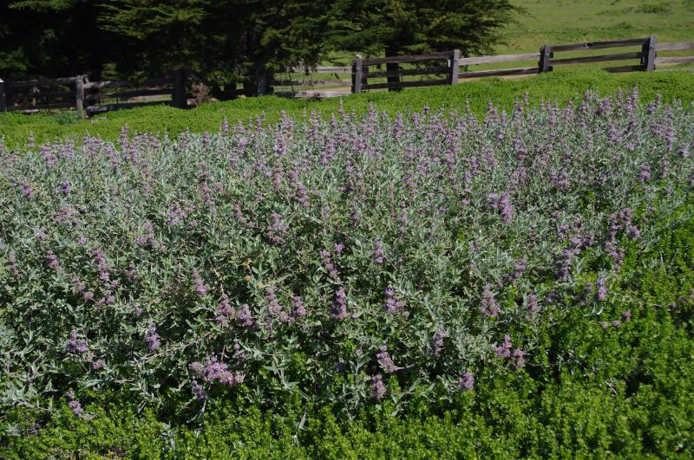
#58B

Scientific Name: Salvia Leucophylla ‘Point Sal Spreader’

Common Name: ‘Point Sal Spreader’ Purple sage
Height: 1 – 2 ft
Width: 6 – 8 ft
Sun/Shade Needs: Sun, part shade
Water Needs: Extremely Low Very Low Low Moderate-High
Attracts: Butterflies, bees and various birds
DESCRIPTION: This low-growing groundcover is a perfect selection for full-sun or part-shade areas. The 'Point sal' variety is a grayish-green leaved, multi-blossomed salvia hybrid that exibits low water needs and has little demand in terms of maintenance. The flowers can be pruned in late fall to produce a good flush in the spring. The lavender flowers are arranged in a circular pattern around the green stems. The flowers attract butterflies, bees, and hummingbirds. Tolerates almost any soil type. Prefers sun in coastal sites, and sun or part shade in inland sites.

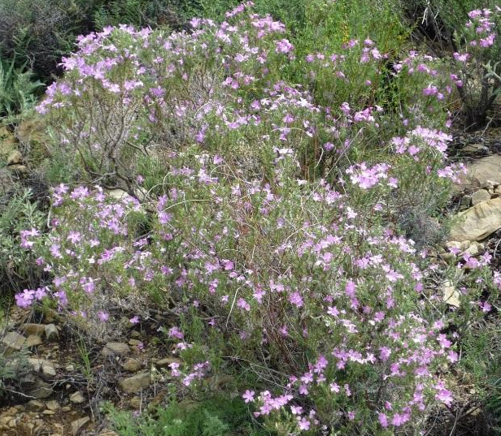
#36B

Scientific Name: Malacothamnus Desiflorus

Common Name: Dense Flower Bush Mallow
Height: 3 – 7 ft
Width: 3 – 7 ft
Sun/Shade Needs: Full sun
Water Needs: Extremely Low Very Low Low Moderate-High
Attracts: Butterflies, bees and many other birds, deer
DESCRIPTION: This is a shrub with a slender, multibranched stem approaching two meters in maximum height. It is coated in thin to dense yellowish or tan hairs. The thick to leathery leaves are oval in shape, a few centimeters long, and sometimes divided into lobes. The flower cluster is a spikelike cluster of many pale pink flowers with oval or triangular petals each up to a centimeter long. Flowers appears in abundance in the spring and early summer. The plant is strong and easy to grow, and extremely drought tolerant. It can handle most soil types as long as they are well draining. In nature it seems to grow best on dry gentle slopes. Avoid summer significant amounts of direct summer water, though it can tolerate a light sprinkling once a month. Does well in full sun or part shade.

